Auto High Beam Telltale - CGEA1.3

Functional Description

The purpose of the Auto High Beam telltale is to inform the driver that the Auto High Beam feature is on and may change the state of the vehicle high beams. In general it is highly preferred for an RTT to be used for this feature due to cost of the fixed telltale and potential issues with customer complaints do to the fixed telltales being more intrusive than the RTT. This telltale or preferred RTT implementation is is incremental to the high beam telltale and is now required in all markets. For ECE countries it is required per regulation ECE 48.

The Auto High Beam telltale correlates the AhbcStat_B_Dsply Signal from the IPMA or AhbStat_B_Dsply signal from the SCCM (based on configuration) and the Operational_Mode to illuminate or extinguish the Auto High Beam telltale.

The Auto High Beam telltale shall provide an iconic representation that will illuminate or extinguish to inform the driver that the Auto High Beam feature is on and may change the state of the vehicle high beams.

Direction is for this telltale to be white in color. As currently there is no color cordinate definitions for a white LED telltale the first program (2018 UP375) shall implement the Auto High Beam Telltale in green. Future programs which elect to use a fixed telltale instead of an RTT shall do the up front development work to develop a white telltale.

Interfaces

Interface Context Diagram (I/O Block Diagram)
Figure 1 Auto High Beam Telltale Interface Context Diagram
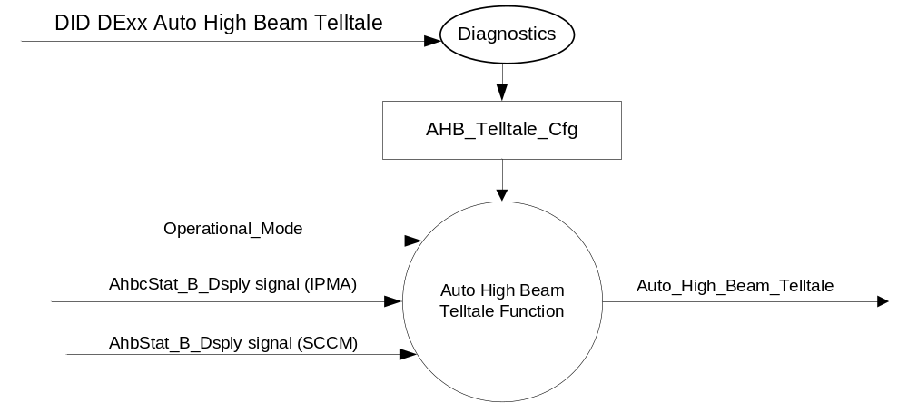

Inputs

      - INTERNAL:
- Operational_Mode
- AHB_Telltale_Cfg
      - MUX message on the CAN Bus

Table 1 AhbcStat_B_Dsply Signal (From IPMA)
Signal Name | Size (bits) | Detail | Units | Res. | Offset | State Encoded | Min | Max
AhbcStat_B_Dsply | 1 |  | SED | 1 | 0 |  | 0  (0x0) | 1 (0x1)
AhbcStat_B_Dsply |  | Off |  |  |  | 0x0
AhbcStat_B_Dsply |  | On |  |  |  | 0x1

Table 2 AhbStat_B_Dsply Signal (From SCCM)
Signal Name | Size (bits) | Detail | Units | Res. | Offset | State Encoded | Min | Max
AhbStat_B_Dsply | 1 |  | SED | 1 | 0 |  | 0  (0x0) | 1 (0x1)
AhbStat_B_Dsply |  | Off |  |  |  | 0x0
AhbStat_B_Dsply |  | On |  |  |  | 0x1

Outputs
Auto_High_Beam_Telltale, which is used to control the state of the Auto High Beam RTT.

Function/Performance

Operational Modes

Mode | Differentiating Vehicle Conditions
Sleep Mode | Auto High Beam Telltale OFF
Limited Mode | Auto High Beam Telltale OFF
Normal Mode | Auto High Beam Telltale ON / OFF
Crank Mode | Auto High Beam Telltale ON / OFF

Voltage Levels

Refer to the Cluster Features table located in Operational Modes and Voltage Range Strategies Section in this SPSS.

Human-Machine Interface

Visual

Indicator Graphics / Display Format

For actual symbol definition refer to database # A.903 of the 03-0685 ARL requirement.

Indicator Color Coordinates

2018 UP375: Green – Reference SDS IL-0017/IS-0379
New Programs: White – Coordinate/Brightness are TBD

Indicator Characteristics

LED – Auto High Beam Telltale

Audio

None.

System Accuracy

The Auto_High_Beam_Telltale shall change the state of the Telltale within 100msec of a state change as indicated in the state matrix reference 1.3.5.1 Subsystem Algorithm Flowchart/ State Diagram

Operation: Performance and Functional

Subsystem Algorithm Flowchart / State Diagram

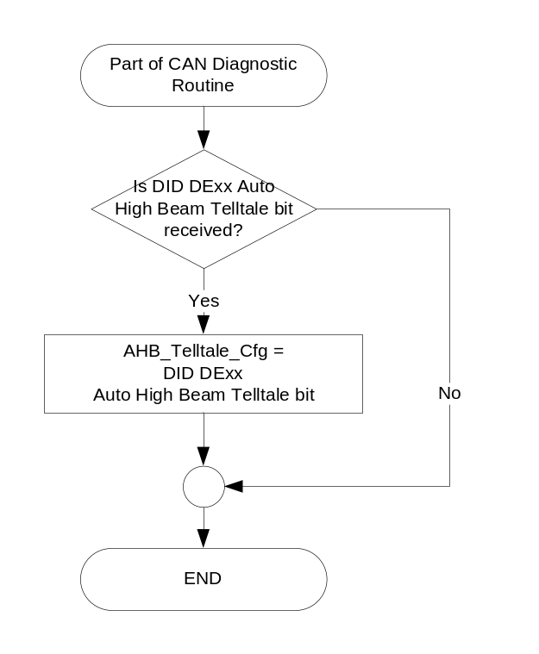

Table 3 State Matrix for Auto High Beam Telltales
Operational  _Mode | AHB  _Telltale  _Cfg | ETM_Bulb  _Check_  State | DIAG  _SESSION  _TIMER | Self_Test_  Entry_Bulb_ Check_Timer | DIAG_DID_  61A5,4,6  (all warning lamps) | AhbcStat_B_Dsply | AhbStat_B_Dsply | Auto_High  _Beam_  Telltale
Normal or Crank | Enabled via IPMA (0x1) | X | NOT ACTIVE | X | X | ON (0x1) | X | ON
Normal or Crank | Enabled via IPMA (0x1) | ON (0X1) | NOT ACTIVE | X | X | X | X | ON
Normal or Crank | Enabled via IPMA (0x1) | OFF (0x0) | X | INACTIVE | Not Received | Missing as per 1.4.1 | X | OFF
Normal or Crank | Enabled via SCCM (0x2) | X | NOT ACTIVE | X | X | X | ON (0x1) | ON
Normal or Crank | Enabled via SCCM (0x2) | ON (0X1) | NOT ACTIVE | X | X | X | X | ON
Normal or Crank | Enabled via SCCM (0x2) | OFF (0x0) | X | INACTIVE | Not Received | X | Missing as per 1.4.1 | OFF
Normal | Enabled via IPMA (0x1) | X | ACTIVE | X | Not Received | ON (0x1) | X | ON
Normal | Enabled via SCCM (0x2) | X | ACTIVE | X | Not Received | X | ON (0x1) | ON
Normal | Enabled via IPMA (0x1) I SCCM (0x2) | ON (0X1) | ACTIVE | X | Not Received | X | X | ON
Normal | Enabled via IPMA (0x1) I SCCM (0x2) | X | ACTIVE | X | ON (0x1) | X | X | ON
Normal | Enabled via IPMA (0x1) I SCCM (0x2) | X | ACTIVE | ACTIVE | X | X | X | ON
All Other Cases |  |  |  |  |  |  |  | OFF

Operation Description (supports algorithm flowchart /state diagram)

  - Auto High beam indication (RTT preferred) shall be implemented on all markets. Telltale implementation as per this section is least preferred implementation.

Function Safety Classification (EMC)

B

Memory Storage

Parameter Name | Description | Value at  Battery Connect | Value at  Module Wake-up
Auto_High_Beam_Telltale | Used to control the state of the Telltale | OFF | OFF
AhbcStat_B_Dsply Signal | CAN signal sent from the IPMA | Off (0x0) | Off (0x0)
AhbStat_B_Dsply Signal | CAN signal sent from the SCCM | Off (0x0) | Off (0x0)
AHB_Telltale_Cfg | Configures cluster to allow Auto_High_Beam_Telltale to be active and to control which signal activates the telltale. Set to Disabled at Cluster Supplier Manufacturing Plant. | Use Stored Value | Use Stored Value
Operational_Mode | 4 state indicator for cluster operational mode | Limited | Limited, Normal or Crank

Prove Out

None

Reconfigurable RTT

RTT is the prefered implementation – only implement as telltale as per this section unless absolutely necessary due to not being able to package dedicated/fixed or Non Toggle RTT.

Message Center Msg

None

Error Handling

Missing Message Strategy

The signals will be declared missing as per the Diagnostics section of this SPSS.

DTCs states and history will be determined as per the Diagnostics section of this SPSS.

Diagnostics

Self Test

Bulb illuminated during self test as per Self_Entry_Bulb_Check_Timer

Engineering Test Mode

Reference section “Dealer / Engineering Test Mode (ETM)”

Part II Performance

Supported Diagnostic Trouble Codes (DTCs)

DTCs shall be logged as per the diagnostic section of this SPSS.

DTC | Description
C23A00 | Lost Communication with Image Processing Module A (IPMA)
C21200 | Lost Communication With Steering Column Control Module (SCCM)

DID DExx
Block  Num | Block Description | Size  (bits) | Type | Byte(s) | Bits | State: Description | "0" | "1" | Default | Comments/  Information
PACKETED BLOCKS
$xx | Option Content (B&A) | 2 | 1 | * | * | Auto High Beam Telltale | Disabled | Enabled | 01
 |  |  |  |  |  | 00 | Encoded | Encoded |  | Disabled
 |  |  |  |  |  | 01 | Encoded | Encoded |  | IPMA as source module
 |  |  |  |  |  | 02 | Encoded | Encoded |  | SCCM as source module
 |  |  |  |  |  | 03 | Encoded | Encoded |  | Unused
*Byte and bit location to be identified in Part II Specification for this cluster

Reference Specification

CR-0030 Adaptive Cruise Control Driver Interface

SC-0190 Speed Control RTT

IS-0001 WARNINGS/INDICATORS/DISPLAYS PROVEOUT
IS-0046 INSTRUMENTATION MATERIAL RESISTANCE TO CLEANING
IS-0052 OPERATING VOLTAGES - FUNCTIONAL/PERFORMANCE
IS-0069 FUNCTIONAL IMPORTANCE CLASS
IS-0324 WINDSHIELD & OTHER REFLECTIONS
IS-0327 WARNING INDICATOR EVALUATION
IS-0329 FLICKERING OF LAMPS
IS-0379 NORTH AMERICAN WARNINGS AND INDICATORS STRATEGY

IL-0017 RTT AND INTERIOR ILLUMINATION COLOR
IL-0021 CRAFTSMANSHIP - DISPLAYS
IL-0023 CLARITY/LEGIBILITY/READABILITY
IL-0025 INTERIOR ILLUMINATION INTENSITY
IL -0027 VISUAL CONTRAST
IL -0043 OPERATIONAL ENVIRONMENT FUNCTIONALITY
IL -0045 COLOR
IL -0047 RTT; INDICATOR AND DISPLAY LIGHT INTENSITY
IL -0048 ILLUMINATION ACCEPTABILITY

03-0661 PLACEMENT: CONTROL AND DISPLAY LOCATIONS
03-0662 PLACEMENT: LOGICAL GROUPING FUNCTION AND USAGE
03-0664 PLACEMENT: DOWN VISION TO COMPONENTS WITH HIGH VISUAL DEMAND
03-0665 PLACEMENT: EXPECTED LOCATIONS OF CONTROLS AND DISPLAYS VDS
03-0670 INTERIOR VISIBILITY
03-0671 INTERIOR VISIBILITY: REFLECTIONS FROM COMPONENTS & SURFACES
03-0672 INTERIOR VISIBILITY: REFLECTIONS IN DISPLAYS
03-0673 INTERIOR VISIBILITY: VISUAL OBSCURATIONS
03-0674 INTERIOR VISIBILITY: ILLUMINATION CONTROLS / DISPLAYS
03-0675 INTERIOR VISIBILITY: VEILING GLARE
03-0677 INTERIOR VISIBILITY: SUNLIGHT WASHOUT
03-0681 IDENTIFICATION: CHARACTER AND SYMBOL SIZE
03-0682 IDENTIFICATION: LEGIBILITY
03-0685 IDENTIFICATION: SYMBOLS, ABBREV FOR CONTROL
03-0721 LOGIC OF OPERATION: OPERATIONAL STEREOTYPES
03-0722 LOGIC OF OPERATION: INTERPRETATION
03-0723 LOGIC OF OPERATION: USE OF SYSTEMS WITH VISUAL DISPLAYS

Revision History

SPSS Module Revision History

Revision Level | Name | Change Description | Date
1.0 | Jblatchf | Initial Release | 11/1/2016

